AI INTERVIEW COACH
Document 7 of 7
Final Deliverables
User manual, technical documentation and maintenance guide, project presentation and demonstration script, optional video, guideline submission checklist and consistency changes.
Item | Detail
Project | AI Interview Coach
Team | Team 147
Course / Track | AI Capstone Project -- Hybrid (Deep Learning / NLP + LLMs & RAG)
Document set | Project Documentation Package (7 documents)
Implementation baseline | GitHub repository Mennatullah-essam/ai-interview-coach, branch main, commit 491f8ae (24 October 2026)
Prepared | 24 October 2026
Status | Draft for academic review

Table of Contents
About This Document
Scope of This Document
7.1 User Manual
7.1.1 About AI Interview Coach
7.1.2 Create an Account and Log In
7.1.3 Upload Your CV
7.1.4 Review and Confirm Your Profile
7.1.5 Set Up an Interview
7.1.6 Answer the Questions
7.1.7 Read Your Feedback
7.1.8 Follow-up Questions
7.1.9 Results
7.1.10 Improvement Plan
7.1.11 History, Performance, Profile and Settings
7.1.12 Troubleshooting
7.2 Technical Documentation
7.2.1 Documentation Map
7.2.2 Maintenance Tasks
7.2.3 Operations Checklist
7.2.4 Future Work
7.3 Project Presentation
7.3.1 Slide Outline
7.3.2 Live Demonstration Script (about 6 minutes)
7.4 Video Demonstration (Optional)
7.5 Submission Checklist
7.6 Consistency Changes to the Earlier Documents

About This Document
This document is Document 7 of the seven-document Team 147 package. Documents 1-3 (Project Planning and Management, Lecturer Review, Requirements Gathering) consolidate the nine original source documents and describe the project as planned. Documents 4-7 (System Analysis and Design, Implementation, Testing and Quality Assurance, Final Deliverables) describe the system as it was actually built, using the repository as the source of truth.
Implementation baseline: GitHub repository Mennatullah-essam/ai-interview-coach, branch main, commit 491f8ae (24 October 2026). Every statement about the system was checked against that code. Where the built system differs from Documents 1-3, the difference is stated and labelled rather than hidden. Status labels used throughout:
Label | Meaning
Implemented | Present in the code at the implementation baseline and exercised by automated tests or an observed end-to-end run.
Implemented (changed) | Implemented in a different form from Documents 1-3, following a recorded decision (API specification D1-D8 or a later milestone decision).
Partially implemented | Present, but narrower than the requirement, or available in the backend only.
Not implemented | Absent from the code at the baseline; the reason (decision, deferral or gap) is stated.
Confirmed / Proposed | As in Documents 1-3: stated in the sources as a decision, or as a proposal not yet confirmed.
Recommendation (review) | Added during this documentation review; not present in any earlier document.
To Be Confirmed | Required information (a date, an owner, a value) is missing or conflicting.

Scope of This Document
Document 7 covers the Final Presentation and Reports phase of the documentation guideline: user manual (7.1), technical documentation (7.2), project presentation (7.3) and optional video demonstration (7.4). It ends with a checklist that maps every guideline item to the document where it is delivered (7.5) and records the consistency changes made to the earlier documents (7.6).
Screenshots come from the implemented application with synthetic test accounts or invented sample records; they contain no real personal data.

7.1 User Manual

7.1.1 About AI Interview Coach
AI Interview Coach helps you practise job interviews. You upload your CV, choose the job you are preparing for and answer interview questions in writing. Every answer is scored and explained, and after each interview you get a practice plan. Scores are automated estimates meant for practice; they are not a judgement of your real-world ability.
- What you need: a recent version of Chrome, Edge, Firefox or Safari, on a computer, tablet or phone.
- Your data: your CVs, interviews and feedback are visible only to you. By default nothing you upload or write is sent to any external AI service. You can delete your practice data at any time (section 7.1.11).
- Answers are typed. Voice answers are not available in this version.

7.1.2 Create an Account and Log In
- Open the application and choose Sign up (top right) or Start Interview.
- Enter your full name, email and a password of at least 8 characters, confirm the password and choose Create account.
- Next time, choose Log in and enter your email and password. You stay signed in on this browser for up to 7 days unless you log out.
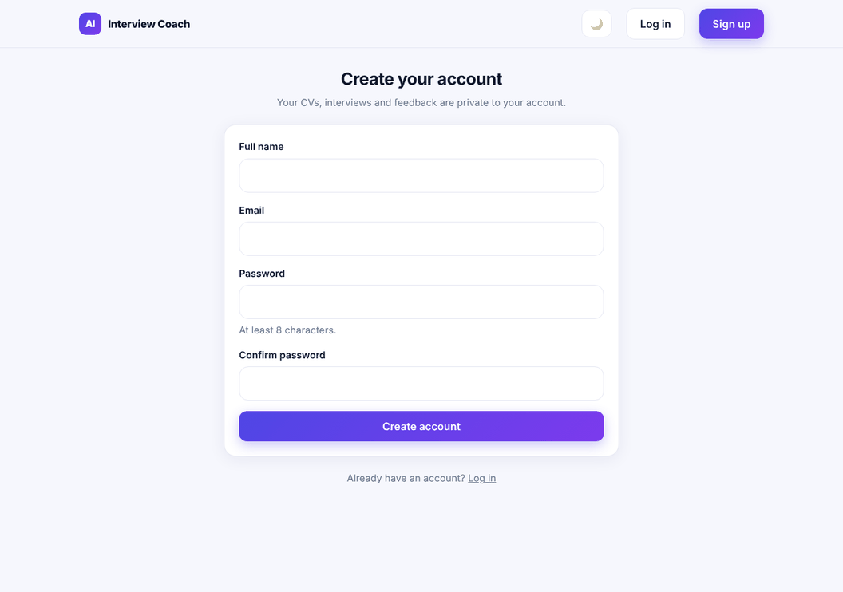
Figure 7.1 -- Create your account

7.1.3 Upload Your CV
- Choose New Interview in the navigation. If you have no CV yet you are taken to Upload your CV.
- Drag your CV onto the upload area or click to choose it. Accepted: PDF or DOCX, up to 5 MB. Scanned (image-only) or password-protected PDFs cannot be read.
- When the upload finishes you can Replace or Remove the file, or Review extracted profile.
- Choose Continue to Job Role to set up an interview.
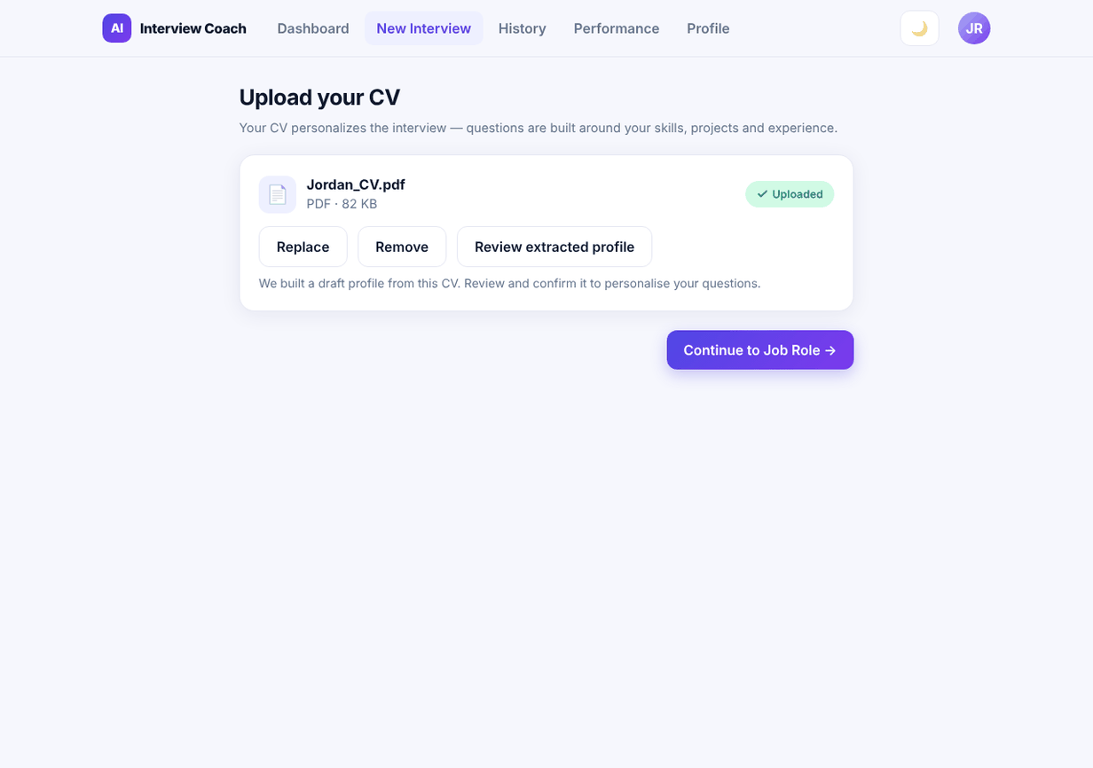
Figure 7.2 -- CV uploaded

7.1.4 Review and Confirm Your Profile
After an upload the system builds a draft profile from your CV: skills, experience, education, projects, achievements and an estimated level and target role. Each item shows where it came from: From CV (with the line it was found in), Inferred (with the reason) or Added by you.
- Open Profile then Review profile (or the link after uploading).
- Remove anything wrong, correct values and add missing skills or projects.
- Choose Confirm profile. Only a confirmed profile is used to personalise interviews (for example questions about your own projects). Interviews never change your profile.
- If you upload a new CV, or choose Re-extract from CV, the profile goes back to draft; items you added yourself are kept.
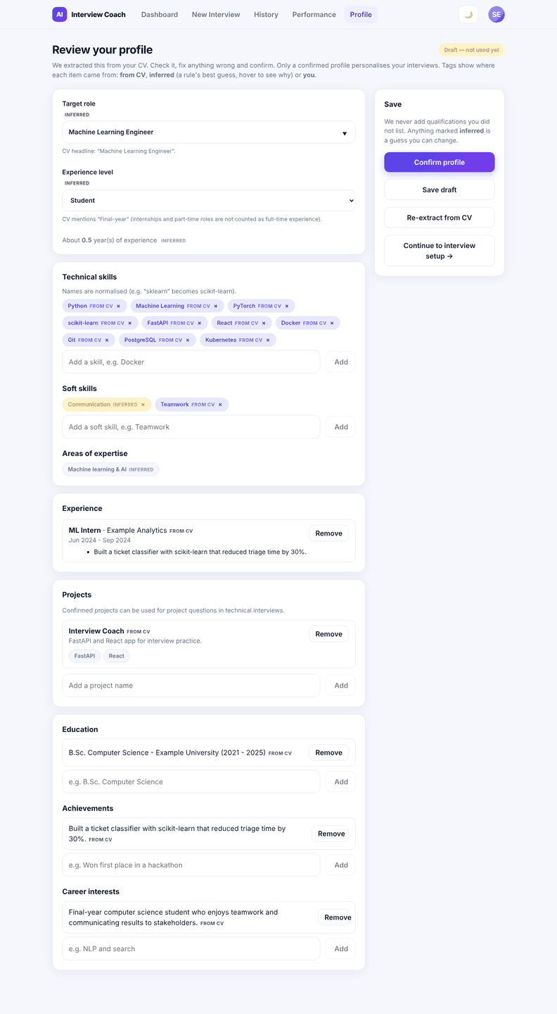
Figure 7.3 -- Profile review

7.1.5 Set Up an Interview
Setting | Options and advice
Target role | Pick one of the seven preset roles or type your own. Preset roles use a list of required and preferred skills.
Interview type | Technical, Behavioral or Mixed.
Difficulty | Beginner, Intermediate or Advanced.
Number of questions | 5, 10 or 15 (about 3 minutes per question).
Job description (optional) | Paste up to 5,000 characters; skills mentioned in it are favoured.
Ask follow-up questions | Turns on adaptive mode: after some answers the coach asks one short follow-up (at most 2, 3 or 4 per interview), and later questions may get easier or harder.

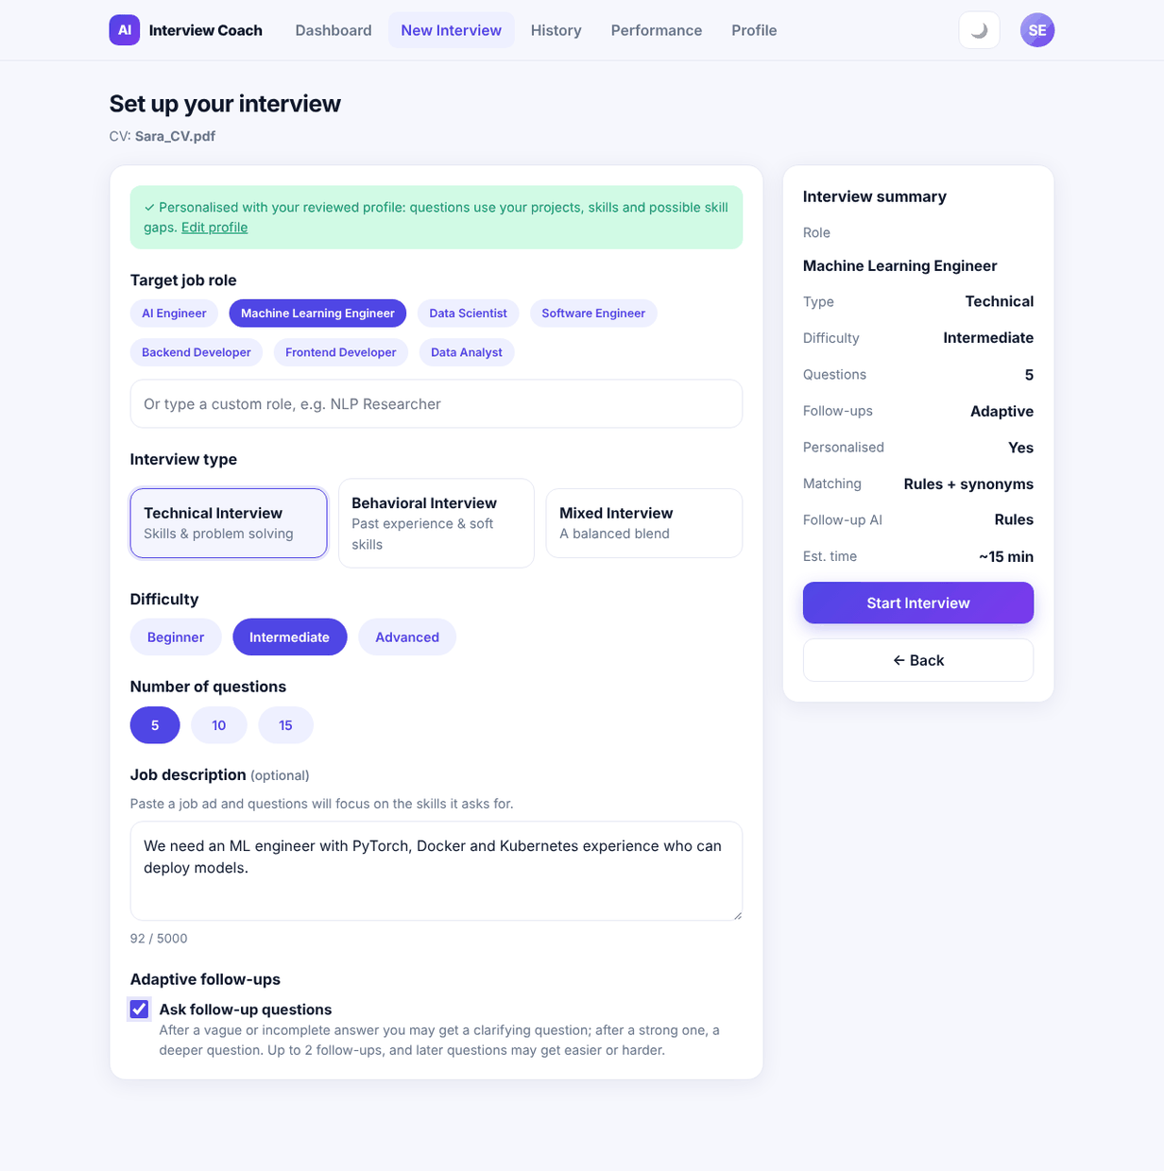
Figure 7.4 -- Interview setup

7.1.6 Answer the Questions
- Read the question. Why this question tells you why it was chosen for you (role skill, your CV, a skill gap, a project or a behavioral competency).
- Write your answer (30 to 1,500 characters). For technical questions explain the idea, how you would apply it and a trade-off; for behavioral questions use Situation, Task, Action, Result.
- Choose Submit answer. Your answer is saved first, then evaluated. Once evaluated it cannot be changed.
- Exit ends the interview after a confirmation; an exited interview is not kept in your history.
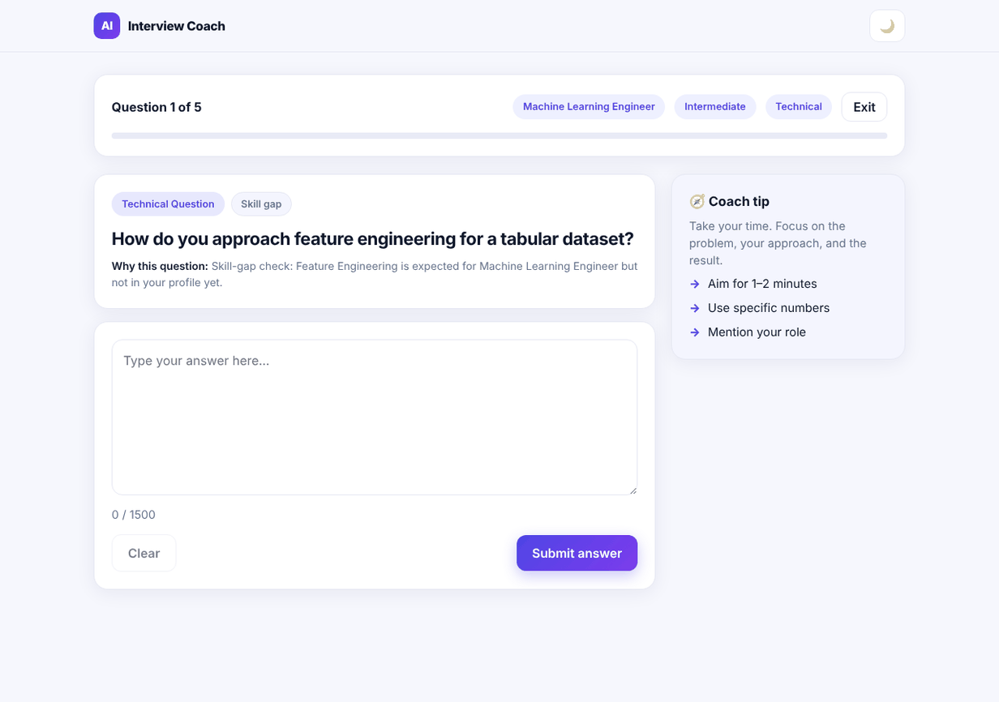
Figure 7.5 -- A question with its reason

7.1.7 Read Your Feedback
Each answer gets an overall score (0-100) and six explained parts:
Part | What it means | How to improve it
Relevance | Does the answer address this question? | Answer the question that was asked first, then add detail.
Key concepts | How many of the expected points you explained. | Explain each point in a full sentence; listing a term is not enough.
Technical accuracy | Technical questions only; lowered by known misconceptions. | Check the concepts flagged as incorrect.
Structure | STAR for behavioral answers; approach, reasoning, example and trade-off for technical ones. | Use a clear order with short paragraphs.
Evidence and examples | Concrete examples, numbers, tools and reasoning. | Add a real example with a measurable result.
Communication | Length, sentence length, repetition. | Aim for a focused answer of a few short paragraphs.

Evidence behind the scores lists each expected concept as Explained, Partly explained, Named only or Not found, quoting your sentence where it was found. If an answer is very short, the coach says the evidence is limited instead of calling it a weakness. View a stronger answer shows a reference answer and its outline.
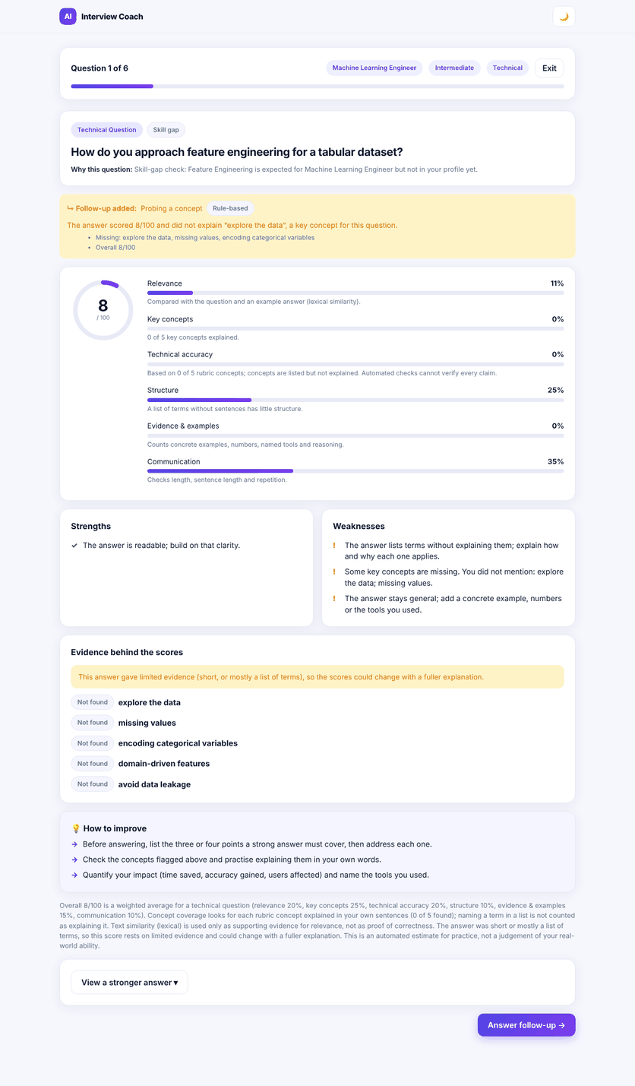
Figure 7.6 -- Feedback for one answer

7.1.8 Follow-up Questions
In adaptive interviews the yellow box explains what the coach decided and why, for example "Probing a concept: the answer did not explain ...". Choose Answer follow-up to continue; the follow-up is scored like any question and appears in your results marked as a follow-up.
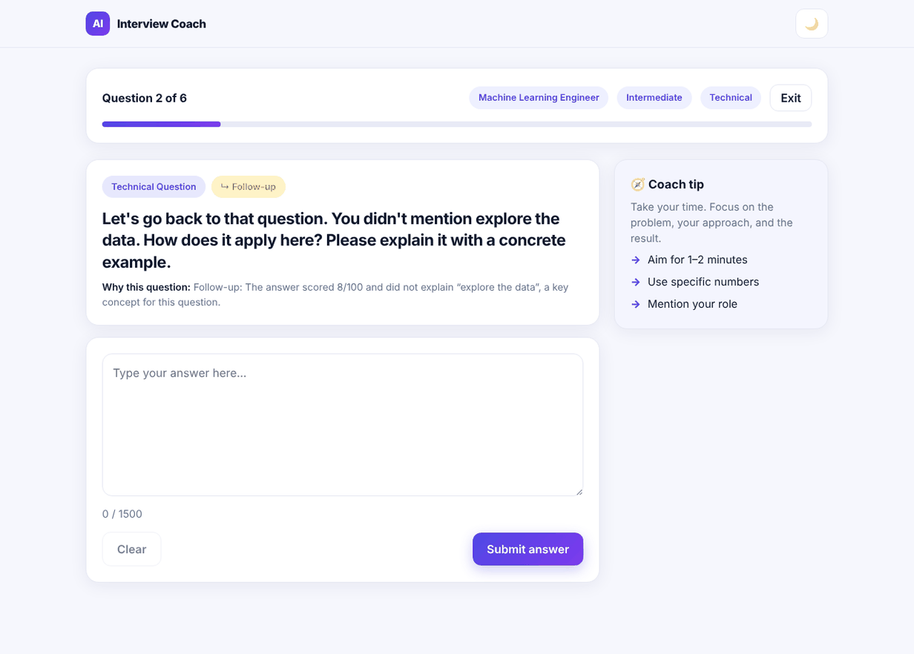
Figure 7.7 -- A follow-up question

7.1.9 Results
After the last question, results show your overall score and label (Excellent 88+, Strong 78+, otherwise Needs Improvement), a breakdown, strengths, areas to improve and three recommendations. Select any question to see your answer and its full feedback.
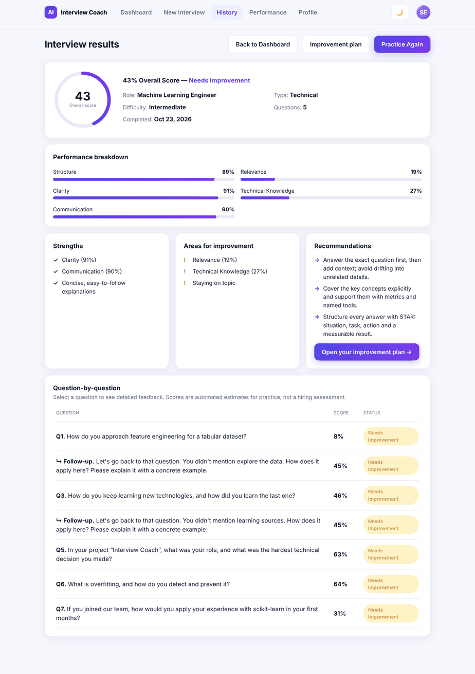
Figure 7.8 -- Interview results

7.1.10 Improvement Plan
Open Improvement plan from the results, the Performance page or the Dashboard. It shows:
- Strengths, marked consistent when they appear in two or more interviews.
- Skill gaps (two or more weak answers on the same skill) with practice questions, an exercise and an official learning resource; a single weak answer is shown as needs more evidence.
- Your competencies: CV versus interviews, which separates what your profile claims from what your answers showed.
- Up to five prioritised next steps and your progress since the previous plan.
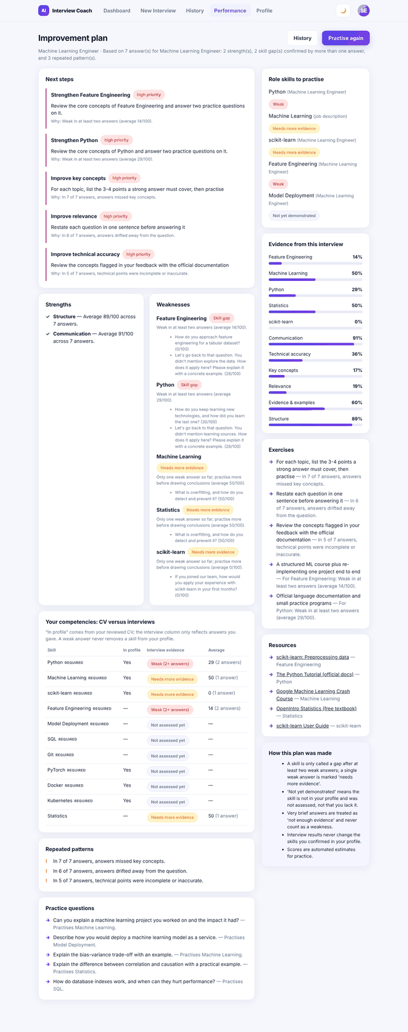
Figure 7.9 -- Improvement plan

7.1.11 History, Performance, Profile and Settings
- History lists completed interviews (filter by type); choose Review to reopen results.
- Performance shows your score trend, scores per skill across interviews and an insight about your strongest and weakest area.
- Profile and settings: change your name or email, open your CV profile, or Delete my practice data (removes CVs, profile, interviews and plans after confirmation; your account stays).
- Dark theme: use the moon/sun button in the top bar; your choice is remembered on this browser.
- Log out from the avatar menu; always log out on shared computers.
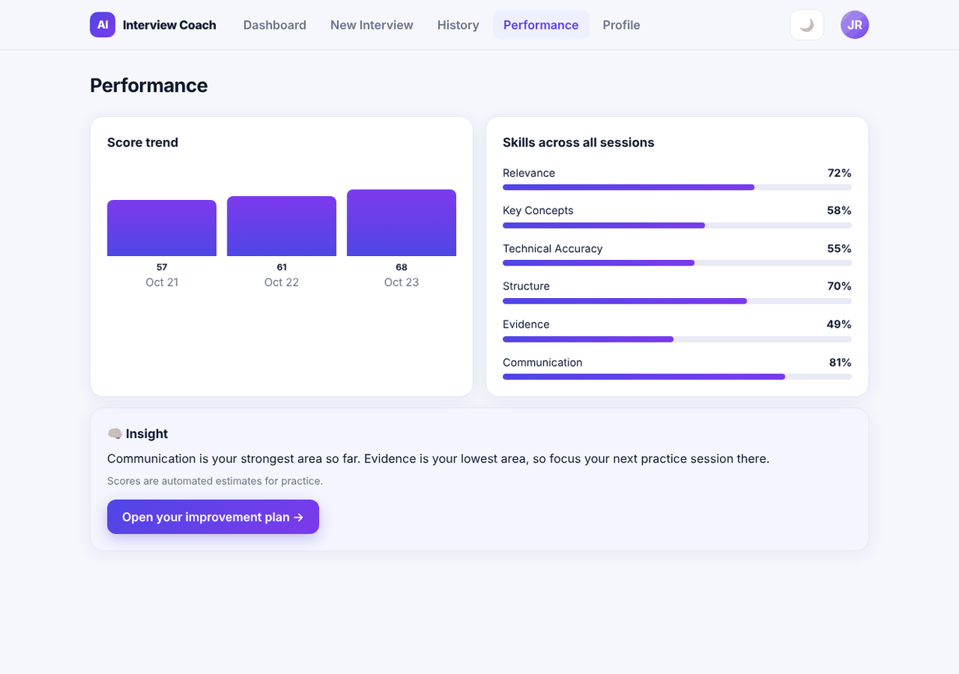
Figure 7.10 -- Performance

7.1.12 Troubleshooting
Message or problem | What to do
"Unsupported format" / "File is too large" | Save the CV as PDF or DOCX under 5 MB.
"We couldn't read any text from this CV" | The PDF is scanned or protected. Export it again from Word or Google Docs as a text PDF.
"Please upload your CV first" | Upload a CV before starting an interview.
"Please write at least 30 characters" / "at most 1,500" | Adjust the answer length.
"Too many attempts" | Wait one minute and log in again.
"Your session has expired" | Log in again; your saved answers are kept.
The page was reloaded during an interview | The interview cannot be resumed from the page yet (known limitation KL-01); start a new interview.
Profile items are missing or wrong | Correct them on the Profile review page and confirm; unusual CV layouts (tables, two columns) are harder to read.

7.2 Technical Documentation

7.2.1 Documentation Map
Topic | Where
Architecture, layers, hybrid intelligence | Document 4, sections 4.4 and 4.13
Database schema, ERD, migrations | Document 4, section 4.5; backend/README.md section 8; backend/alembic/versions
API endpoints, examples, error codes | Document 4, section 4.14; /docs (OpenAPI); backend/README.md section 7; API_SPECIFICATION.md (original contract and decisions)
Data flows and behaviour (DFD, UML) | Document 4, sections 4.6-4.10
Installation, configuration, running | Document 5, sections 5.5 and 5.8; README.md; backend/README.md sections 3-4
Coding standards, version control, CI/CD | Document 5, sections 5.3, 5.6, 5.7
Tests, benchmark, bugs | Document 6; backend/tests; backend/scripts/benchmark_intelligence.py
Deployment | Document 4, section 4.16; Document 5, section 5.10; Dockerfile; DEPLOY_AZURE.md (branch deploy/azure)
Requirements and planning | Documents 1-3

7.2.2 Maintenance Tasks
Task | Steps
Add or edit a question | Edit backend/app/data/question_bank.json (text, type, difficulty, role and skill tags, reference answer, key points, optional misconceptions). Run pytest tests/test_scoring_and_selection.py (bank checks), then python scripts/seed_question_bank.py (idempotent).
Add a preset role | Add it to roles.json with required and preferred skills that exist in skill_catalog.json / skills.txt; add it to the frontend role list in src/data/constants.js.
Change scoring weights or thresholds | Edit backend/app/scoring/config.json, change its `version`, run the tests and the benchmark, and compare with benchmarks/m5_lexical.json before merging.
Change the database schema | Edit app/models, run alembic revision --autogenerate -m "...", read and correct the generated file (constraints, data migration, downgrade), alembic upgrade head, pytest with TEST_DATABASE_URL.
Enable the local embedding model | pip install -r requirements-ml.txt, set SIMILARITY_BACKEND=sbert, restart; vectors are cached in storage/embedding_cache/.
Enable an LLM | Run a local server (for example Ollama), set LLM_PROVIDER=openai_compatible, LLM_BASE_URL, LLM_MODEL; a hosted server additionally needs LLM_API_KEY, LLM_ALLOW_EXTERNAL=true, a team decision and a privacy notice (NFR-036).
Back up and restore | pg_dump -Fc -f backup.dump <database>; restore with pg_restore -d <database> backup.dump. Always back up before a migration on shared data.
Rotate the JWT secret | Set a new JWT_SECRET and restart: all users must log in again. Rotate database passwords on the host and update DATABASE_URL.

7.2.3 Operations Checklist
- GET /health (process alive), GET /health/db (database reachable), GET /api/v1/health (readiness, database and intelligence mode).
- Logs go to standard output; on Azure Container Apps use az containerapp logs show --follow.
- Users report errors with the request id shown in error responses (X-Request-ID).
- Cold start after scale-to-zero takes 20-60 seconds; warm the app before a demonstration.

7.2.4 Future Work
- Deploy publicly and record the link (Document 5, 5.10); add monitoring and alerts (FR-071 to FR-073).
- Validate scoring against human ratings and measure the local embedding model (Document 6, 6.6).
- Frontend resume of interrupted interviews; skip question; single-session and account deletion; password reset by email.
- Voice answers with speech-to-text (FR-035 to FR-038) once text scoring is validated.
- Optional generation of questions and ideal answers with an approved LLM provider, behind the existing policy checks (decision D4 review).
- Persistent rate limiting and CV object storage for multi-instance hosting.

7.3 Project Presentation
The presentation file is AI_Interview_Coach_Final_Presentation.pptx (14 slides with speaker notes, dark theme matching the application's dark mode, screenshots of the real application with sample data). It can be saved as PDF from PowerPoint. The outline below is its content; every figure in it comes from Documents 4-6.

7.3.1 Slide Outline
# | Slide | Content
1 | Title | AI Interview Coach, Team 147, course and track, date.
2 | The problem | Generic preparation, scarce mock interviews, subjective self-assessment (Document 1, 1.1.2).
3 | Our solution | CV-aware interview practice with explained scoring and a tracked improvement plan; the user journey in five steps.
4 | The product (or live demo) | Setup, session and results screens; live demo script in 7.3.2.
5 | Architecture | React SPA, FastAPI layers, deterministic-first hybrid intelligence, PostgreSQL (Document 4, Figure 4.2).
6 | How an answer is scored | Six dimensions, concept evidence, claims, evidence level; similarity is only supporting evidence.
7 | The interview agent | Five actions, policy checks, optional LLM that can only propose; 98.6% appropriate decisions, 100% fallback.
8 | Personalisation and coaching | Role, job description and confirmed profile drive selection; required-skill coverage 0.667 to 0.856; repeats 76.4% to 21.4%; plan v2.
9 | Security and privacy | Accounts, token rotation, per-user isolation, private CV storage, no CV text to any AI service by default.
10 | Quality and testing | 272 automated tests, 34 browser checks, benchmark (held-out agreement 63.0% to 70.4%), bug log highlights.
11 | Challenges and decisions | No paid AI (D4) -> curated bank and explainable rules; AWS unconfirmed (D8) -> container + free hosting path; paraphrase weakness of the lexical engine; hosting attempts.
12 | Planned vs delivered | Objectives O1-O6 status; what was deferred (voice, GenAI generation, AWS monitoring) and why.
13 | Next steps | Deploy, human-rated validation, embedding benchmark, CI, frontend resume, user study.
14 | Team and roles; questions | Six members and their areas (Document 1, 1.3.1).

7.3.2 Live Demonstration Script (about 6 minutes)
Time | Action | Point to make
0:00 | Open the landing page; sign up a new test account. | Accounts and privacy.
0:40 | Upload the prepared synthetic CV; open Profile review; correct one item and confirm. | Provenance: from CV, inferred, added by you.
1:40 | Set up a 5-question Machine Learning Engineer interview with follow-ups on. | Personalisation and the active intelligence notice.
2:20 | Answer the first question weakly (a list of terms). | Concept evidence: named only; agent probes a missing concept.
3:20 | Answer the follow-up well. | Score rises; feedback explains why.
4:20 | Finish quickly with prepared answers; open Results. | Breakdown, recommendations, question details.
5:00 | Open the Improvement plan; then Performance. | Gap versus needs more evidence; CV versus interviews.
5:40 | Log in as a second user and show empty data. | Per-user isolation.

Prepare before the demonstration: the synthetic CV, the prepared answers, a warmed-up server, and a recorded fallback video in case the network fails (Risk R04 contingency).

7.4 Video Demonstration (Optional)
Status: Not started. Recommended storyboard: record the live script in section 7.3.2 at 1280 x 720 with captions (3-5 minutes), using only synthetic data, and add the link to README.md and this section.

7.5 Submission Checklist
Table 7.1 maps every item of the project documentation guideline to the place where it is delivered.
Table 7.1 -- Guideline coverage
Phase | Guideline item | Where | Status
1 Planning | Project proposal; plan with Gantt, milestones, deliverables, resources | Document 1, 1.1-1.2 | Done
1 Planning | Task assignment and roles; risk plan; KPIs | Document 1, 1.3-1.5 | Done
2 Lecturer review | Feedback and evaluation; suggested improvements; grading criteria | Document 2 (lecturer feedback and marks to be filled in by the lecturer) | To Be Confirmed
3 Requirements | Stakeholders; user stories and use cases; FR; NFR | Document 3 | Done
4 Analysis and design | Problem, objectives, use case diagram, FR/NFR, architecture | Document 4, 4.1-4.4 | Done
4 Analysis and design | ERD, logical and physical schema | Document 4, 4.5 | Done
4 Analysis and design | DFD, sequence, activity, state, class diagrams | Document 4, 4.6-4.10 | Done
4 Analysis and design | Wireframes/mock-ups, UI/UX guidelines | Document 4, 4.11 | Done
4 Analysis and design | Tech stack, deployment and component diagrams | Document 4, 4.12-4.13 | Done
4 Analysis and design | API documentation, testing and validation, deployment strategy | Document 4, 4.14-4.16 | Done
5 Implementation | Source code, standards, modularity, security and error handling | Repository; Document 5, 5.2-5.4, 5.9 | Done
5 Implementation | Repository, branching, commit history, CI/CD | Document 5, 5.6-5.7 | Partial
5 Implementation | README (installation, requirements, configuration, execution, API) | README.md, backend/README.md; Document 5, 5.8 | Done
5 Implementation | Packaged application and deployment link | Dockerfile (container image); link pending | Partial
6 Testing | Test plan and test cases; automated tests; bug reports | Document 6 | Done
7 Final | User manual; technical documentation | Document 7, 7.1-7.2 | Done
7 Final | Presentation (PPT/PDF) | AI_Interview_Coach_Final_Presentation.pptx | Done
7 Final | Video demonstration (optional) | Section 7.4 | Not started

7.6 Consistency Changes to the Earlier Documents
To keep the seven documents consistent, the following changes were made to the earlier files when this package was prepared. Their content was otherwise left unchanged because they are the record of the plan and the requirements.
File | Change
01 Project Planning and Management | Cover and "About This Document" now refer to a package of 7 documents and point to Documents 4-7 for the implemented system.
02 Lecturer Review | Same package reference. No feedback, marks or grading values were added: they must come from the lecturer.
03 Requirements Gathering | Same package reference; note that the implementation status of every FR and NFR is traced in Document 4, section 4.3.
Project Handbook | Updated to the built system: AI components and their real status, repository structure (frontend at the root), current test results, deployment status (Hostless cause, prepared Azure path), document map.

